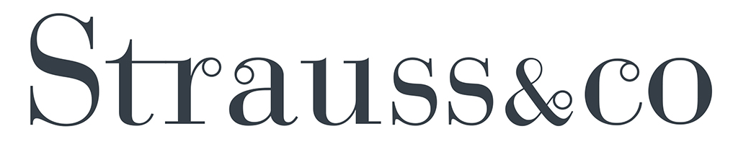

PRESS RELEASE - 30 January 2020 – for immediate release
Strauss & Co’s biggest Contemporary Art Sale yet offers the cream of pan-African talent in south africa’s mother city, en fete with the cape town art fair
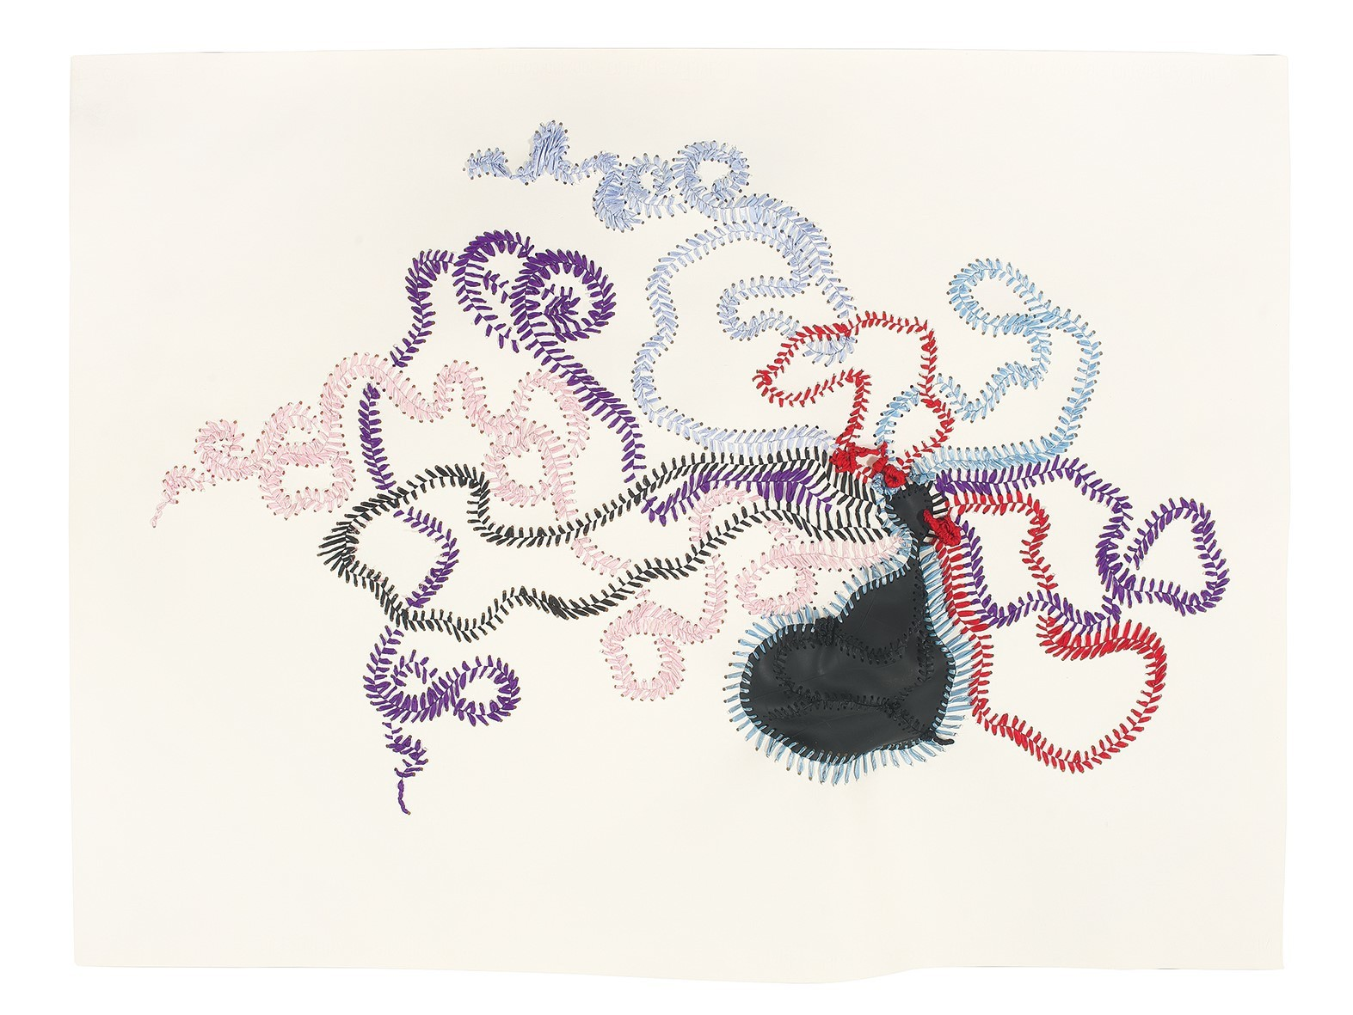
Nicholas Hlobo’s embroidered ribbon assemblage piece Umphokoqo (estimate R400 000 – 600 000).

A new wave of internationally celebrated South African artists, among them Nicholas Hlobo, Athi-Patra Ruga and Simphiwe Ndzube, lead Strauss & Co’s much-anticipated Contemporary Art auction, due to be held in Cape Town on 15 February. Many of the artists have already established international profiles with top awards and critically acclaimed exhibitions.

Now in its third year, this benchmark annual Strauss & Co sale coincides with the Investec Cape Town Art Fair and will feature 102 carefully vetted lots, amongst which is a single owner consignment of pan-African works from a leading South African collector.

For savvy art lovers sick of the northern winter all roads lead to Cape Town in February, for it is Art Week as the grape harvest comes in and the Cape is one huge party. The city is hard to beat as a destination - exciting, vibrant and warm - with the best AFRICAN CONTEMPORARY ART FOR SALE at Strauss & Co.

In February Cape Town is packed to the brim with art collectors, curators, artists and art aficionados from all over the world. The Cape Town Art Fair is of international standard and attracts a global audience. Parties, exhibition openings, artist performances, studio visits and central to it all, is the Strauss & Co private preview and auction..

Commenting on the overall scope of the sale, Strauss & Co joint managing director Bina Genovese says: “Strauss & Co’s 2020 contemporary art sale represents our biggest offering to date. It is also our most representative sale, both in terms of gender and nationality. Collectors wanting to learn more about this exciting, future-orientated category are urged to participate in our vibrant educational and social programme in the lead up to the sale.” Genovese will reprise her role as lead auctioneer at the sale.

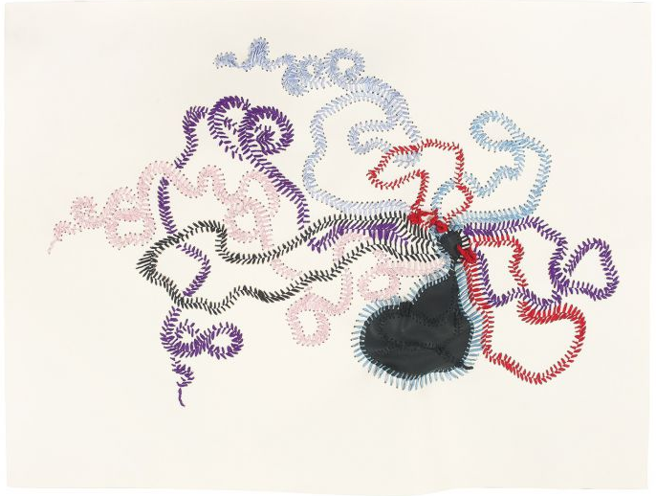
Highlights from the forthcoming sale include Nicholas Hlobo’s embroidered ribbon assemblage piece Umphokoqo (estimate R400 000 – 600 000). This is the first time a work of this calibre by this highly rated artist will appear on the secondary market in South Africa.

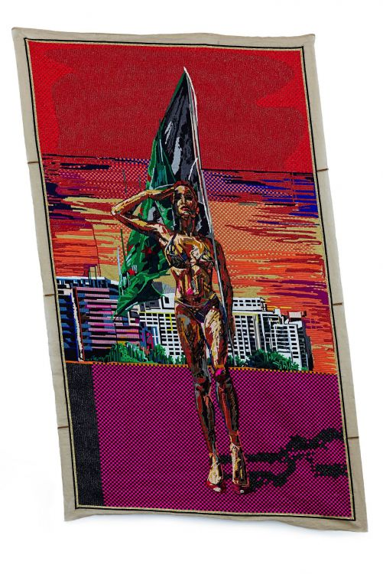
Athi-Patra Ruga’s wool and thread on tapestry canvas, Touched by an Angel (estimate R700 000 – 900 000), is a pop-political allegory depicting a Rihanna-esque bad girl clad in a bikini bearing a flag. The estimate reflects sustained interest in Ruga’s textile work over the last five years. In 2019 Strauss & Co sold Ruga’s photograph, The Night of the Long Knives I, for R1.7-million, a world record.

The youngest artist in the trio, Simphiwe Ndzube, winner of the 2015 Michaelis Prize, is represented on the sale by an early-career photo triptych, In Search Of (estimate R120 000 – 160 000). The pageantry enacted in his tableaux vivants heralded the subjects and themes of his current painting practice.

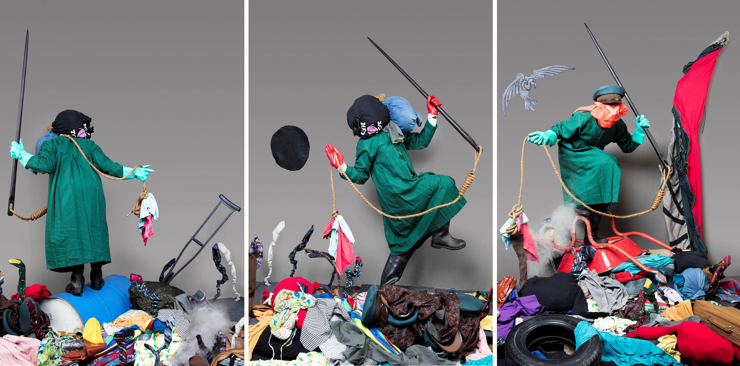
Simphiwe Ndzube, triptych, In Search Of (est R120 000 – 160 000)

All three artists have enjoyed significant international attention in the last year. Now based in Los Angeles, Ndzube appeared on the 2019 Lyon Biennale, an important early-career milestone for artists, and was recently the subject of a video profile by Vanity Fair. Hlobo and Ruga have both been involved in high-profile collaborations with French luxury goods brands.

Commissioned by Louis Vuitton, Hlobo’s limited edition “ArtyCapucines PM” handbag features a bright blue hand-embroidered decoration and a flower blooming from the interior of the bag. Ruga’s Lady Dior bag, for fashion house Dior, depicts a face embroidered with pearls, fabric and metal flowers and crystals.

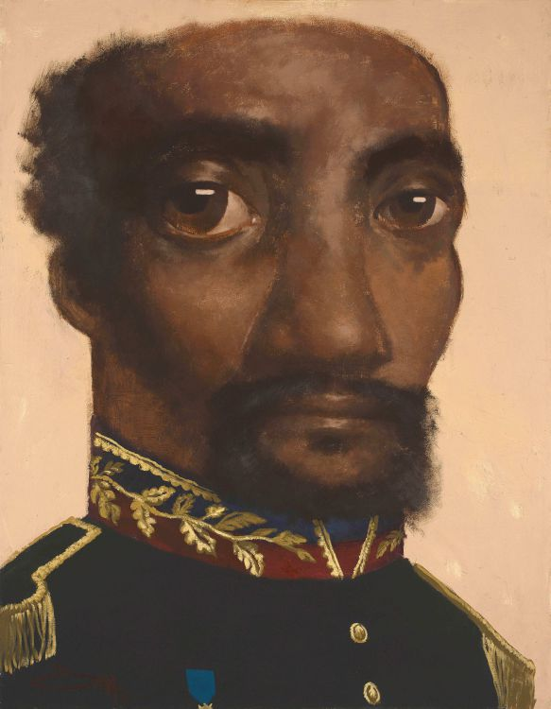
Strauss & Co is proud to be offering 22 lots from the Property of a Collector. Encompassing drawing, painting and sculpture, the consignment includes a number of works by contemporary African artists with international presence, among them painters Cyril Omamogho (Nigeria), George Lilanga (Tanzania), and photographers Omar Victor Diop (Senegal) and Hassan Hajjaj (Morocco).
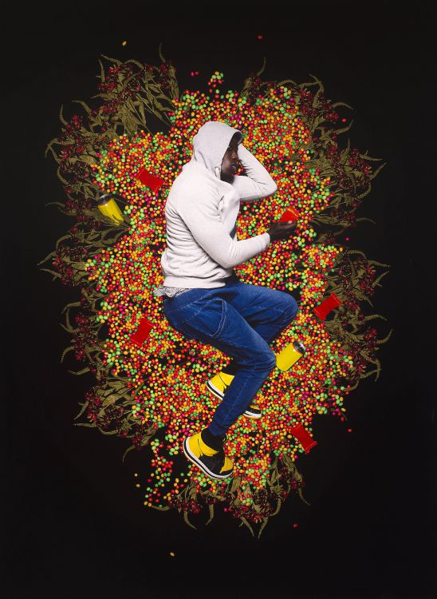
Based in Marrakech, Hajjaj’s vibrant portraits of Moroccan youths last year featured in his career survey at the photography museum Maison Européenne de la Photographie, Paris. An edition of Diop’s performance portrait Trayvon Martin, 2012 (estimate R150 000 – 200 000) is currently being exhibited on a survey of new African art at the Astrup Fearnley Museum of Modern Art in Oslo, Norway.
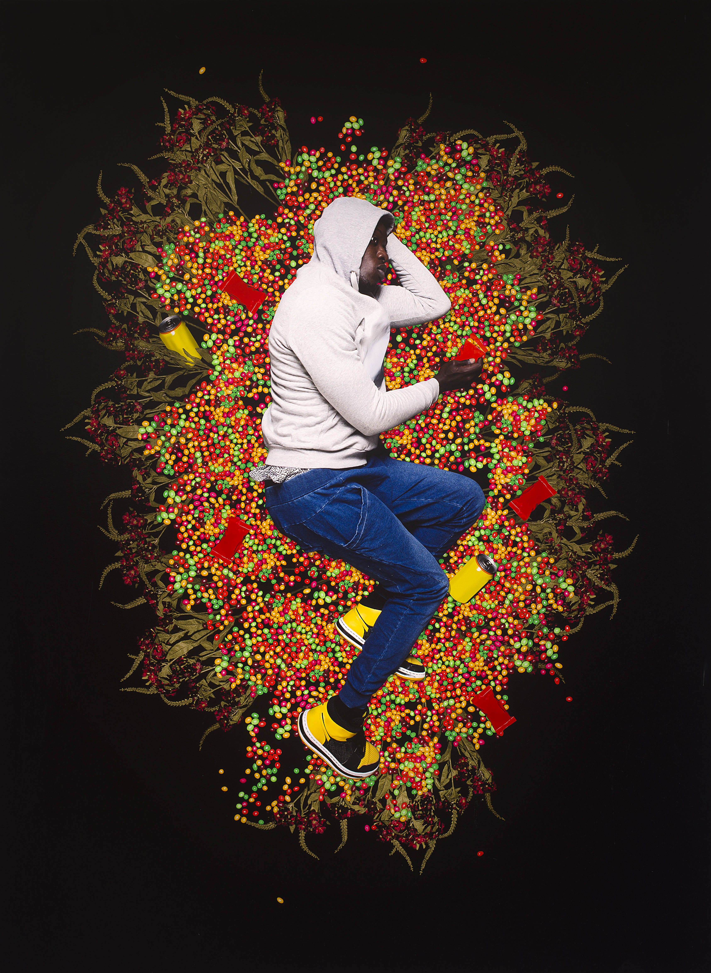

“I am proud of the range and depth of the works on offer in this sale,” says Matthew Partridge, contemporary art specialist at Strauss & Co who heads up the sale. “The sale highlights a broad range of artistic strategies, from painting to photography, defining this current moment. The 22 lots from a South African collector provide insight into how these practices can be combined into a coherent pan-African collection.”
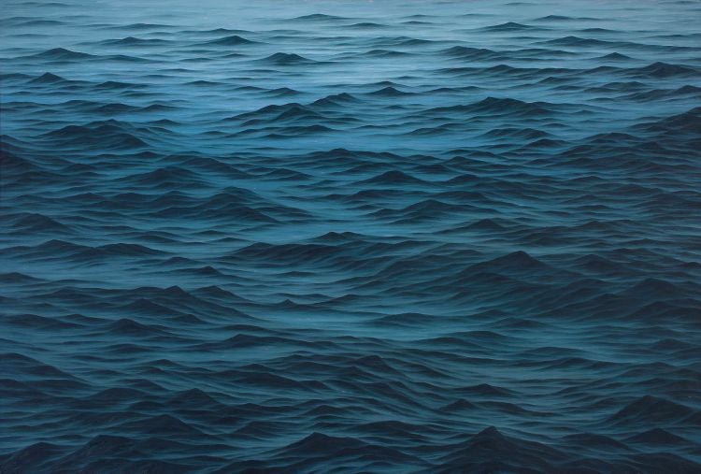
Paintings feature strongly in the upcoming sale, with noteworthy works by Jake Aikman, Lisa Brice and Georgina Gratrix on offer. The catalogue also includes an untitled floral study from 2015 by in-demand portraitist Cinga Samson (estimate R70 000 – 90 000).

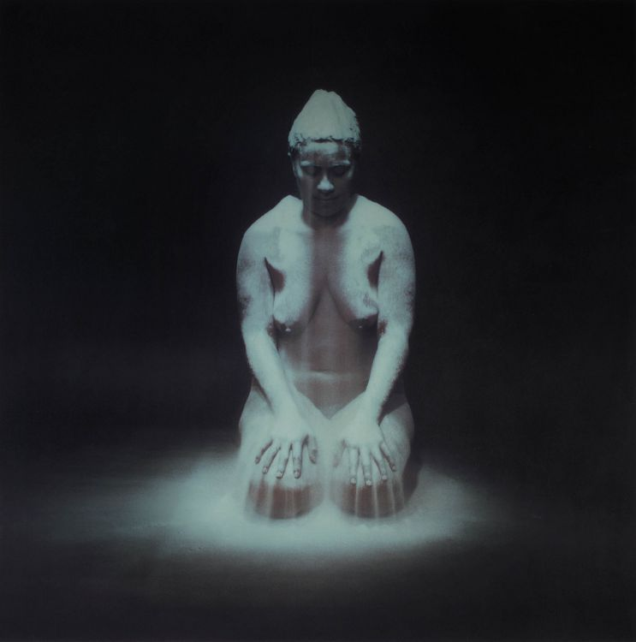
There is also a special focus on photography. The photography session opens at lot 32 with an important 2001 work by Berni Searle, Still (estimate R200 000 – 300 000), from the Property of Kangra Group (Pty) Ltd, assembled by the late Graham and Rhona Beck. The lot comprises eight semi-transparent photographs of the artist kneeling, covered in flour, in the process of kneading dough, and is based on a video installation shown at the 2001 Venice Biennale.

“Searle’s influence is deeply felt in South African visual art, where a whole generation of artists, including Athi-Patra Ruga, Mohau Modisakeng, Zanele Muholi and Nandipha Mntambo, share a common lineage in Searle’s staged photography and video work,” says Partridge.
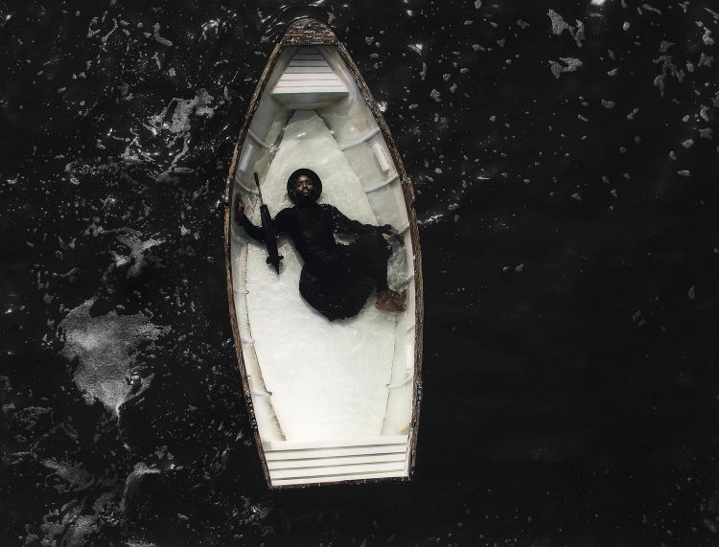
Modisakeng and Muholi, who each have a work in the photography session, are also alumni of the Venice Biennale. Modisakeng’s Passage 7 (estimate R180 000 – 240 000) is a self-portrait of the artist stranded in a rowing boat and is based on a three-channel video projection presented in the South African Pavilion at the 2017 Venice Biennale. Strauss & Co was a co-sponsor of the pavilion.
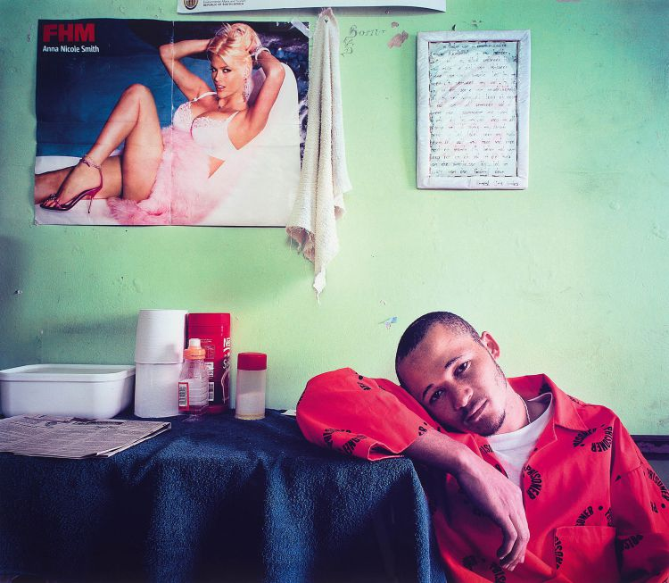
The contemporary sale features a number of past winners of the prestigious Standard Bank Young Artist Award. Aside from Modisakeng, they include
Jane Alexander, Pieter Hugo, William Kentridge, Mary Sibande, Mikhael Subotzky and Nontsikelelo Veleko. The sale also includes an untitled canvas (estimate R150 000 – 200 000) by Blessing Ngobeni, the 2020 recipient of this career-defining accolade.

Executed in 1993-94, Alexander’s tableaux sculpture, something’s going down (estimate R800 000 – 1 million), presents four diminutive figures moving in a procession along a ramp painted in military camouflage. “Alexander’s sculptures are seldom offered at auction and this is a rare opportunity to acquire a work in this medium by this preeminent South African artist,” says Partidge.

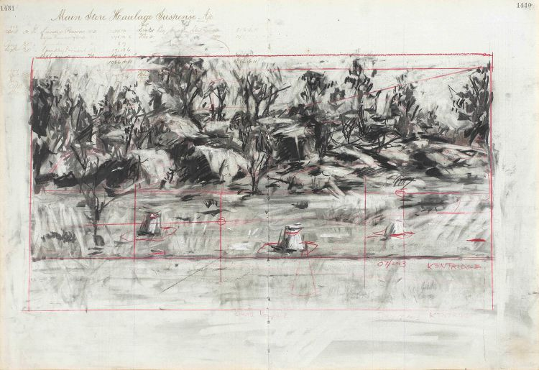
Kentridge’s important charcoal drawing Small Koppie 2 (estimate R1.5 – 2 million) forms part of the consignment from the South African collector and depicts the low hill in the Marikana area where police killed 34 striking miners in August 2012. Kentridge visited the site as part of his drawing process.

Strauss & Co’s third contemporary art sale will take place on Saturday, 15 February 2020 at 6pm at Quay 7 Warehouse, 11 East Pier Rd, V&A Waterfront, Cape Town. (GPS: 33°54'05.4"S 18°25'27.9”E)

Contemporary Art
Including the Property of a Collector

Saturday 15 February 2020 at 6 pm
Bubbly and canapés from 5 pm

VENUE: Quay 7 Warehouse, 11 East Pier Road, V&A Waterfront, Cape Town

PREVIEW: Thursday 13 and Friday 14 February, from 10 am to 5 pm | Saturday 15 February from 10 am to 6 pm
LECTURES AND WALKABOUTS
Sunday 9 February at 11 am: Fluid Horizons, Extremities and the Vanishing Point
conducted by Prof Karel Nel, renowned artist, curator, collector and intrepid traveller
Venue: The Norval Foundation Atrium, 4 Steenberg Road, Steenberg Estate, Tokai;
Admission: Free with museum admission

Thursday 13 February at 10.30 am: Contemporary Art: A New Collecting Practice
conducted by Matthew Partridge, Contemporary Art Specialist, Strauss & Co
Venue: Quay 7, 11 East Pier Road, V&A Waterfront, Admission: Free

Friday 14 February at 10.30 am: Contemporary African Art
conducted by Wilhelm van Rensburg, Senior Art Specialist, Strauss & Co
Venue: Quay 7, 11 East Pier Road, V&A Waterfront, Admission: Free

ENQUIRIES AND CATALOGUES
+27 (0) 21 683 6560 | +27 (0) 78 044 8185

CONTACT NUMBERS DURING PREVIEW AND AUCTION: Tel +27 (0) 78 044 8185 | +27 (0) 72 337 8405

ABSENTEE AND TELEPHONE BIDS: Tel +27 (0) 21 683 6560 | +27 (0) 78 044 8185 | bids@straussart.co.za

PAYMENT: Tel +27 (0) 21 683 6560 | +27 (0) 11 728 8246 | debbie@straussart.co.za

CONDITION REPORTS: conditionreports@straussart.co.za

ILLUSTRATED CATALOGUE: R220.00
All lots are sold subject to the conditions of business printed at the back of this catalogue

www.straussart.co.za

